**Lab1(yuxuanz6)**

**Introduction**

Lab 1 will be due on Sunday, Feb 4th, 23:59pm.

About score:

The full score is 100. There will be 2 points deduction for every hour late, with a maximum of 15 hours. Namely, the maximum point deduction you'll get from a late submission is 30. We encourage you to finish the work eventually (and get some credit) even if it's late.

Score break down:

1. Lab Report, in PDF format, commit to your Git repo (50%)

 - Section 4.1 Q(1) (5%); Q(3) (10%)

 - Section 4.7 Q(a) (5%); Q(b) (5%)

 - Section 5 bullet point questions. (15%)

 - A picture of your topology, with interface and IP addresses. (10%)

2. Demo (50%)

   Each of you will be signing up for a 5 minute appointment with a course staff, and demo your GNS3 setup. Sign up sheet will be sent out later.

**Section 4.1**

Q(1) (5%) (1)Please take a few minutes to think about the issues below. Sit back and close your eyes. Pretend you really do want to start your own ISP. How would you design the topology? How specifically would you go about answering the questions above? Do a few google searches - can you uncover any information to help you take some first steps? Suppose you are meeting with your investors tomorrow and you need to tell them what moves you are making, you really have to tell them a plan. What topology would you make if you had to do it right now? Write a paragraph or so with your thoughts.

First of all, I will make the real problem into a model. Here, I will make it into 2 providers connect to my ISP. We all have a few PoPs inside our ISP. I have three now. We must figure out what kind of protocols are used between our ISPs. Second, I have to look inside my own PoPs and figure out the locations to set them. The way to find most suitable locations are from distance cost, data handling , transmission speed, local revenues etc. Third, I will find the most comfortable control and data protocols between my PoPs, make sure they will handle the traffic and send the packets properly. Fourthly, do some extra plan in case there are some failures happened. For example, make extra PoPs connect to some part of my PoPs and use them only in emergency. Finally, simulate and run the model, design some filters to take the specific traffic according to the need, and design fire wall in some parts of the PoPs to protect attacks such as Doc attacks.

Q(3) (10%) (3) Answer the following questions (in your lab write up)

(a) What do you think about the topology, overall? Do you have any ideas to make it better?

The problem here is like two providers ISP and they connect to my own ISP. Customers are in the bottom of the chain. Each provider is running one ISP and inside ISP, there are few PoPs. For me, I have three PoPs now which are in Chicago, Seattle and California. I will draw providers’ ISPs equally and PoPs inside each, and then my ISP in the second level connect to them. In the bottom, I will draw customers’ ISP.

(b) What do you think about the resilience of this network? If a router fails, or a link fails, are your customer well protected?

The network now has some protections. If one provider fails, other one still send packets. If my PoP in Seattle fails, the traffic will become heavy but it will still go through from Chicago and California, since it is a triangle shape. If we want to improve it, we have to add more PoPs properly.

(c) There are no firewalls here. Only routers. Is that ok? Is that safe?

It definitely becomes unsafe. It will be ok in most common situations since we will set protocols properly. However, if sometime there are attacks, with no firewalls, our business will be unsafe. Thus, we have to design firewall to each of our PoPs to make it safe.

(d)What would you do if there was a huge increase in traffic between site1 and site2? What bad things might happen? What are some of your options to mitigate the situation?

In good case, the transmission speed between site1 and site2 becomes slower. In bad case, site1 and site2 crashed and got disconnected. I will design a PoP between site1 and site2. In normal time, it will not be used. If the site1 or site 2 detect a huge increase in traffic, they will give some traffic to that PoP. The PoP here should burden suddenly change of the traffic and heavy traffic.

**Section 4.7**

Next, we will configure policies to limit route export. We will consider routers R4 and R5 to be providers, and router R6 to be a customer of the ISP containing R1, R2 and R3, as shown in Figure 2.

Q(a) (5%)(a) If router R4 advertises a route, which routers should receive that route? What about if router R5 advertises a route? What about if router R6 advertises a route?

In my lab1, before using community commend, there are no filters indeed. Therefore, if R4 as the provider advertises, R1-R3 and R6 are supposed to receive that route. If R5 as the provider advertises, R1-R3 and R6 are supposed to receive that route. If R6 as the customer advertises, R1- R3 are supposed to receive that route, R4,R5 as it providers are supposed to receive as well. The problem here is how to design filters so that if a provider advertises, the parallel providers will not receive any information from him and customer should receive all its provider advertises.

Q(b) (5%) (b) Modify your configuration (hint: you may want to do this by tagging route advertisements with a community attribute indicating what kind of peer they are received from, and then also add an export filtering rule for providers that filters routes from customers. An example of this is shown below.) Print your configuration files as well as the terminal output of ”show ip bgp”, and attach them to your write up.

Note : my code file for this part separates from the original BGP file.

**Section 5 bullet point questions. (15%)**

• Suppose you’re working for a large enterprise network. Your upstream provider is Sprint. You maintain a BGP peering with Sprint at two separate PoPs. You wake up on Friday and your users can’t send traffic to the Internet. How would you debug the issue? Please give details.

The problem is like a triangle model, one upstream provider and two customers. I would like to check that mainly from two aspects. One is from intra-domain routing protocols such as OSPF,RIP. Using related software like GNS3 and using “show ip route” command to check what two PoPs connecting status are. On the other hand, I will check inter-domain routing protocols such as BGP. Using command “show ip bgp summary” to check whether Sprint has the right connections to my two PoPs. Those are two main debug methods I will first to do.

• You fix the above issue but then late the following week you get hit with a major DoS attack. The attack targets your web infrastructure and is overloading your servers, but not any part of your network infrastructure. The traffic is composed of SYN floods sourced from IP address range 175.45.176.0/24. How do you protect your servers from this attack?

I have the following ways to protect my servers :

1. Change the IP to different range and make sure it can hold all my servers. For example :175.45.176.0/24 to 175.45.176.0/28, it will hold all my servers because it enlarge the servers, and servers will also need to change their IP length from 24 to 28 accordingly.
2. If keep IP range to 24, first find out and disconnect all the servers and devices using 175.45.176.0/24; second, change IP 175.45.176.0/24 to 175.0.0.0/24 or other IP properly; third, design filter code to get rid of all the relative upcoming connections with 175.45.176.0/24.

• You fix the above problem but a week later a new problem comes up - you have too much traffic going over one of your links. Describe in detail how you would get traffic to shift to the other PoP (both inbound and outbound).

Suppose the upper provider is R1, one with two much traffic is R2, and the other one I want shift some traffic is R3.

Inbound : Add one PoP R4 between R2,R3, and set R4’s intra-domain protocols like OSPF so that traffic will also shift to R3 from R2 through R4. We could add more PoPs between R2 and R3. In same idea, I can also configure more interfaces in R2 and R3, using intra-domain protocols like OSPF to connect them properly.

Outbound : Add one provider R4 between R1,R3, and set R4’s inter-domain protocols like BGP so that traffic will also shift to R3 from R1 through R4. We could add more providers between R1 and R3. In same idea, I can also configure more interfaces in R1 and R3, using inter-domain protocols like BGP to connect them properly.

**A picture of your topology, with interface and IP addresses. (10%)**

Main :

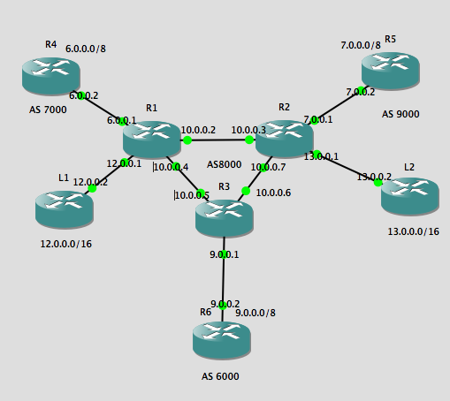

OSPF :

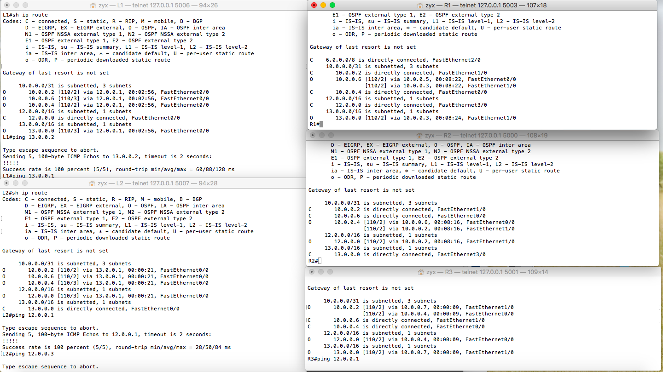

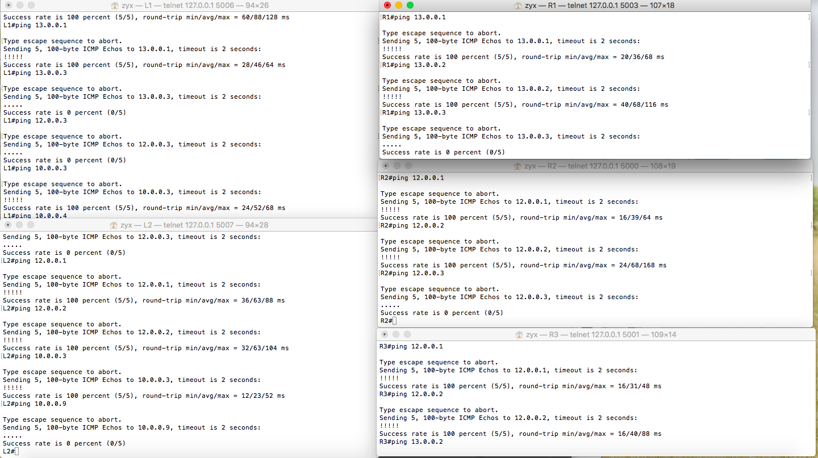

BGP :

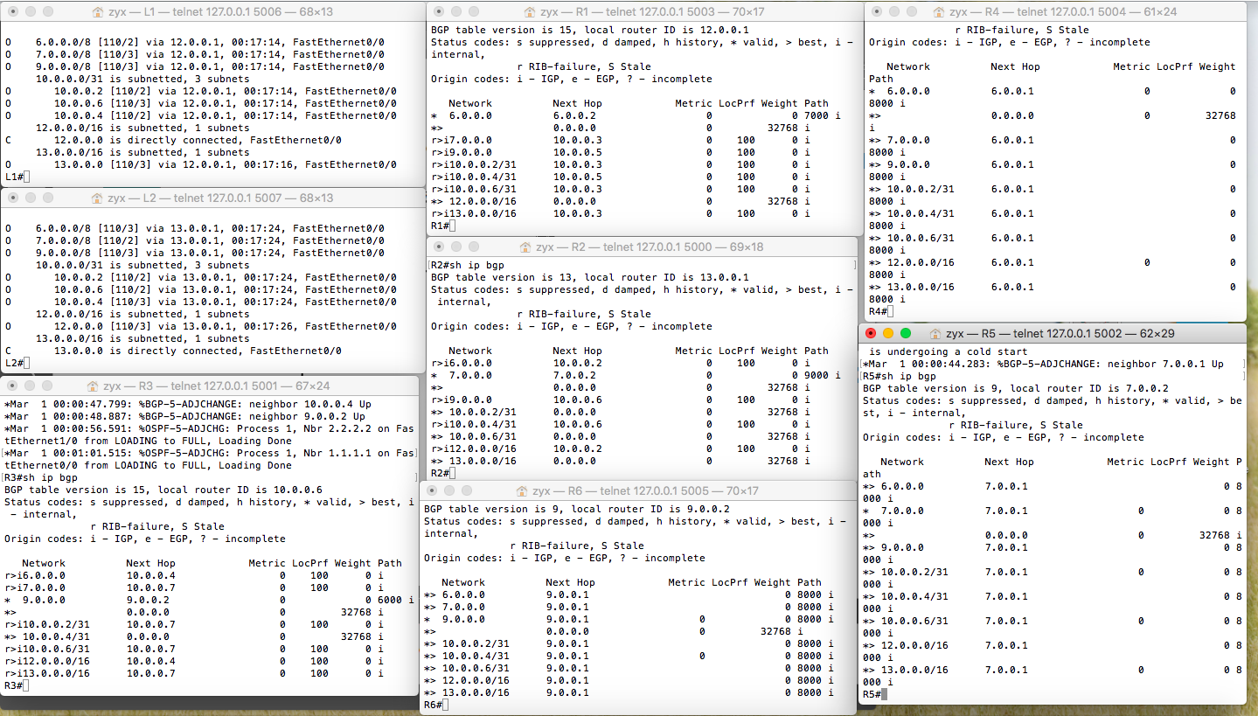

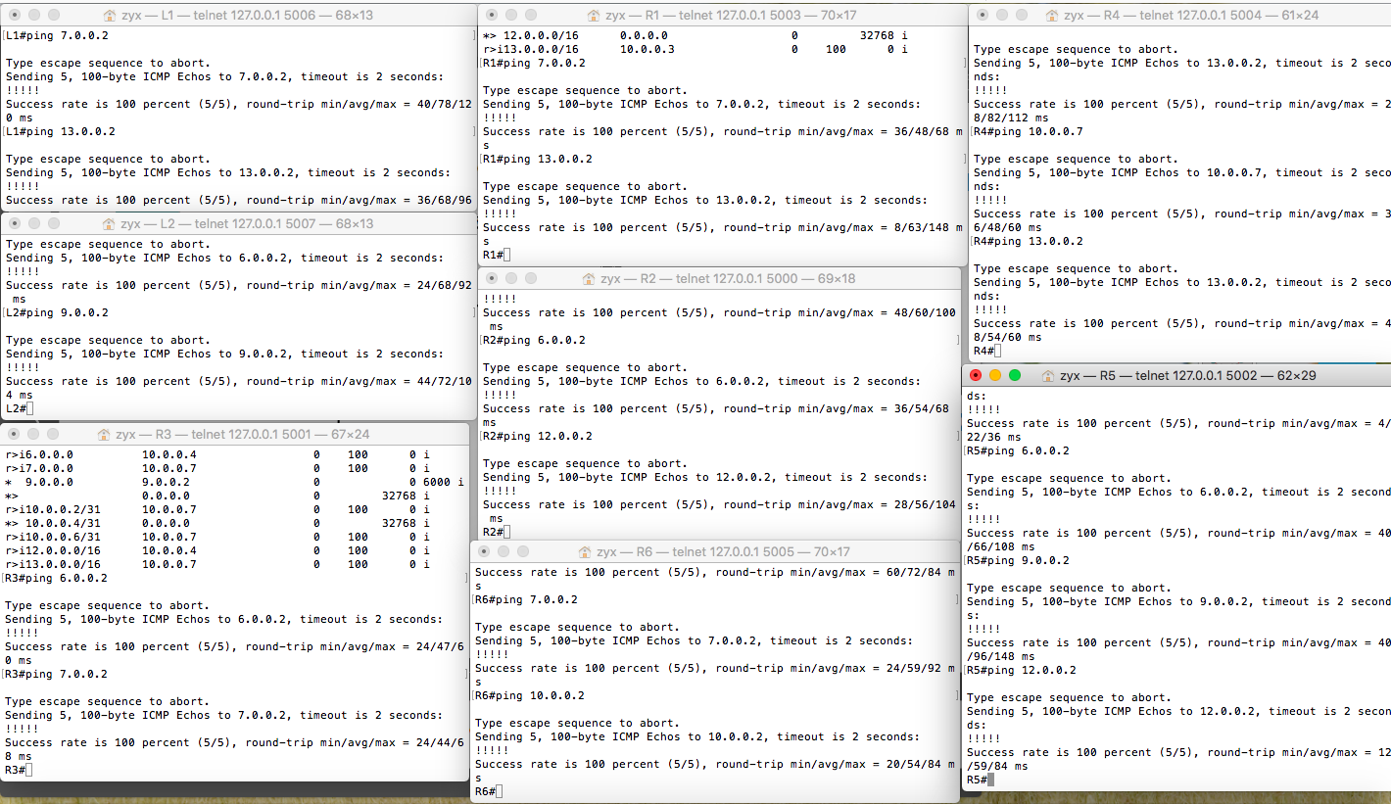

BGP with filter (community) design :

